**ACT1601: Fundamental of financial accounting**

Instructor: A. Issorasak Santivitoonvongs

อิศรศักดิ์ สันติวิฑูรวงศ์

Tips in learning this course.

* Pay attention especially for the first 3 chapters because it will create a strong basic knowledge for your best understanding.
* You have to practice the assignments assigned.

We shall have two quizzes. 1st Quiz before midterm, and 2nd quiz before final. Dates will be informed later.

**MARKS ALLOCATION:**

* Quiz I and Quiz II (3% + 3%) 6%
* Attendance + Assignments 4%
* Mid-term exam 40%
* Final exam 50%

# **TOTAL 100%**

**What is Accounting?**

The definition of accounting which was given by AICPA (American Institute of Certified Public Accountant)

Accounting is the language of business. Accounting is also an information system because it contains Input, process and output.

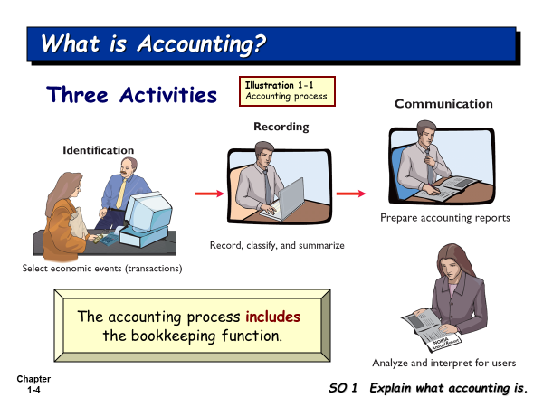

There are a lot of events occurred every day in the business. Some events are not economic events. The accountant will record only the economic events. So, accountants have to analyze the events whether the events are economic events or not.

Identification is the most difficult activity. If you do this activity mistake, other activities will be mistake too. This activity concerns about how we analyze the economic events before we go to Recording. Identification in Accounting here is select and analyze.

The output of accounting is the accounting reports which will be submitted to the interested users.

Accounting reports (Financial Statements) include

1. Income Statement
2. Retained Earnings Statement
3. Statement of financial position
4. Cash Flow Statement
5. Note disclosure

**Who uses the accounting data?**

There are internal users and external users.

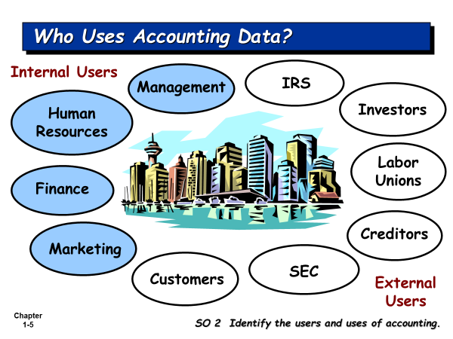

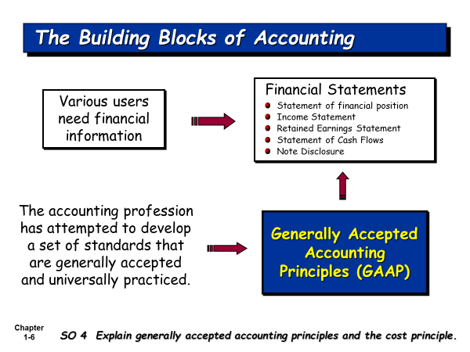

The financial statements are prepared based on GAAP.

**What is GAAP?**

**Generally Accepted Accounting Principles (GAAP)** is the standard framework of guidelines for [financial accounting](http://en.wikipedia.org/wiki/Financial_accounting). It includes the standards, conventions, and rules accountants follow in recording and summarizing transactions, and in the preparation of statements.

**Who developed GAAP?**

The accounting profession develops it.

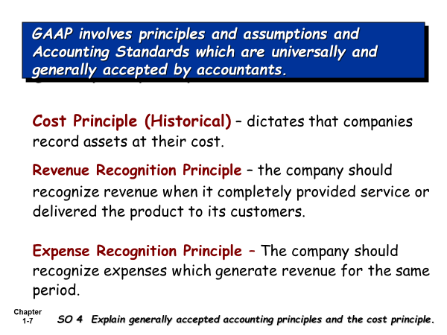

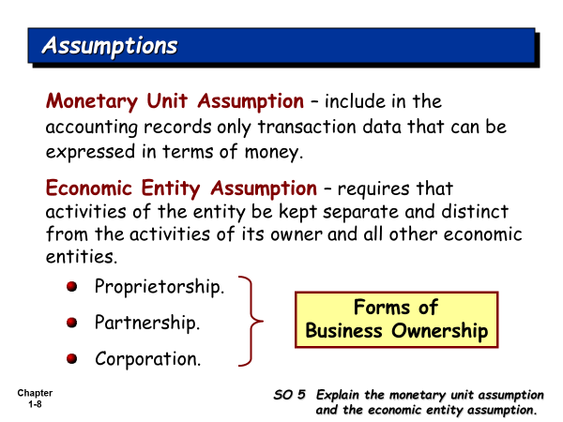

**Set up his company**

**Owner Organization (business firm)**

**Accountant** has to record the transactions for the business firm, not for the owner, because the accountant must hold the Economic Entity Assumption, that is, Owner and his business firm are the separate entity.

**Table 2.1 Some Accounting Concepts**

|  |  |
| --- | --- |
| **Basic Accounting Concepts** | **What It Means in Relationship to a Financial Statement** |
| **1. Separate Economic Entity Assumption** | Owner and his business firm are the separate entity. Shareholders are the separate entity from their company. |
| **2 Going Concern Assumption** | It is assumed that once the business firm is opened, the owner will run his business into the future quite long enough until he can meet his objectives. |
| **3. Monetary Unit Assumption** | An economic entity's accounting records include only quantifiable transactions. Accounting must be recorded using a stable currency e.g., the U.S. dollar, Thai Baht |
| **4. Time Period Assumption** | Most businesses exist for long periods of time (Going Concern Assumption). The accountant will artificially divide it into an equally time period, i.e., the company’s accounting period, which can be monthly, quarterly, and annually. We need to report the performance of our company under each accounting period. |
| **4. Historical Cost Principle** | **A**ssets are reported and presented at their original cost, e.g., our company bought equipment at 100,000 Baht, we record it at cost. |
| **5. Matching Principle (or Expense Recognition Principle)** | The matching principle requires that expenses incurred be matched with revenues generated from these expenses for an accounting period. |
| **6. Revenue Recognition Principle** | Revenue will be recognized (recorded) when our company’s service has been completed, or product has been delivered to customers, even money has not yet been collected. |
| **7. Full Disclosure Principle** | The full disclosure principle requires that financial statements include disclosure of information that is important to the users of the financial statements. It can be disclosed in the notes to the financial statement. |
| **9. Materiality** | Some expenses are very small, like taxi fare, stamps and so on, the accountant prefers to record them in one account, such as, Miscellaneous Expense. |
| **10. Conservatism Concept** | Under the uncertainty situation, the accountant will under-estimate the revenue and assets, and will over-estimate expenses and liabilities. |

1st act period (Jan 1- Dec 31)2nd act period (Jan 1, 2022 – Dec 31, 2022)

Jan 1, 2021 Dec 31,2021

I start my business on Jan 1, 2021. I will run my business quite long enough until I can meet my objectives. How can I measure the performance of my business firm? I want to know whether my business firm can make profit or not? We use the time period assumption to divide the life of our business firm into an equal time period. We call it Accounting period. The companies in Thailand have accounting period of 1 year.

Net Income = Revenues - Expenses

How do you record the revenues for the period? You will follow the Revenue Recognition Principle.

How do you record the expenses for the period? You will follow the Matching Principle (or Expense Recognition Principle).

**There are 3 forms of business ownership**

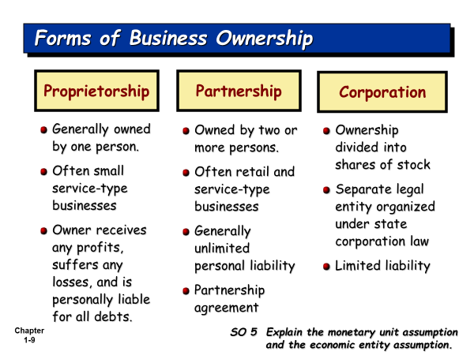

**Types of Business Operation**

1. Service business. The company sells the service (Complete/Provide service) to customers. Normally, this business is owned by one person, i.e., single proprietorship, e.g. Repair Shop, Barber shop, etc.
2. Manufacturing business. The company produces the products and sells the product to customers.
3. Merchandising business: The company buys the products, and then sells the product to customers.

**Fields of Accounting**

1. **Financial Accounting:** The accounting reports will be presented to the internal and external users
2. **Managerial or Cost Accounting:** The managerial accounting reports will be used by the managers of all levels for their planning, directing, and controlling of their operations.
3. **Tax determination and planning**
4. **Public Accounting/ or Independent audits**
5. **Data processing and information systems /or Accounting information systems**
6. **National income accounting**

**Accounting Profession/or accounting career paths**

1. Accountants and accounting Manager in the private firms
2. Certified Public Accountant (External Auditor): Many accounting students wants to work with the BIG4 Companies. The Big4 Companies are the international audit firms, like, PricewaterhouseCoopers, Ernst & Young, Deloitte Touche Tohmatsu, and KPMG.
3. Cost accountant and Cost Account Manager
4. Internal Auditor
5. Tax Planning Officer/ Tax Planning Manager
6. Accounting System/Information System Designer
7. Government Accountant
8. Business Consultants

There are two accounting bases: - Cash Basis Accounting and Accrual Basis Accounting.

**Cash Basis Accounting** is the accounting method that revenues are recognized only when the company receives cash, and expenses are recognized only when the company pays cash.

**Accrual Basis Accounting is** the accounting method that recognizes revenue when they are earned (Revenue Recognition Principle), even cash has not yet been received; and recognizes expenses when they are incurred, even cash has not yet been paid (Matching Principle). Accrual basis accounting is considered to be the standard accounting practice for most business companies in the market. GAAP recommends all business companies to use Accrual Basis of Accounting.

**Accounting Equation is the start of accounting recording.**

**What is the transaction?**

**Accountant must select** and analyze the transactions which have an impact on the Accounting Equation.

**Assets = Equities**

*Resources of the firm = Sources of the firm’s resources*

Assets are the resources of the firm. Equities are the source of the firm’s resources

**Assets = Equity of creditors (Liabilities) + Equity of owner**

*Resources of the firm Rights of creditors’ claims on the firm’s Rights of Owner’s claims resources on the firm’s resources*

How many forms of business ownership?

**Sole (Single) Proprietorship**

**Assets = Liabilities + Owner’s Equity**

**Partnership**

**Assets = Liabilities + Owners’ Equity**

**Corporation**

**Assets = Liabilities + Stockholders’ Equity**

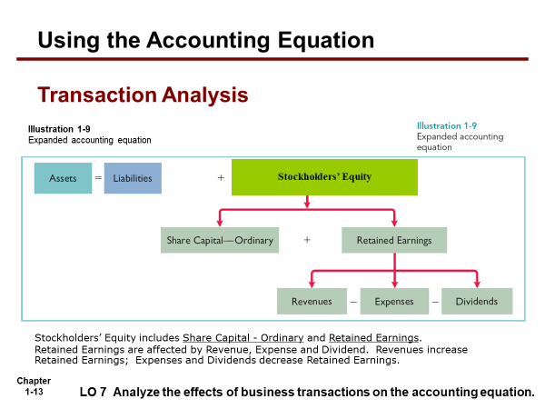

*Note: For intensive accounting, we focus on how to do the accounting record for single proprietorship; while the course Act1600 and Act 1601, we focus on how to do the accounting record for corporation.*

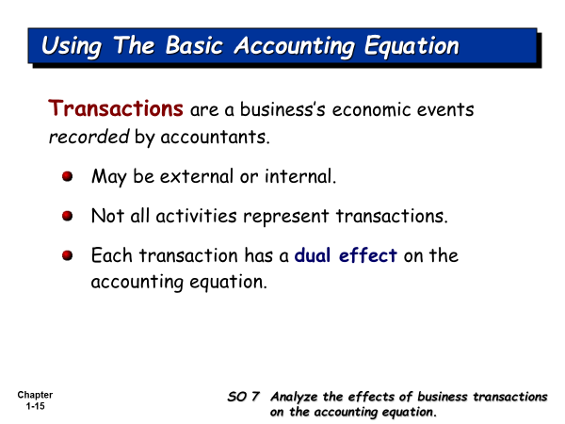

**We can apply accounting equation for your personal life recording.**

**Assets = Liabilities + Parents’ Equity**

**Assets = Claims of creditors (Liability) + Parent’s Claim**

Cash + Book + Calculator = Supplier’s Claim + Friend’s Claim + Mother Capital

+1,000 = +1,000

- 800 + 800 .

**Bal. 200 + 800 = +1,000**

- 200 + 1,000 = + 800 .

**Bal -0- + 800 + 1,000 = + 800 +1,000**

+500 = +500 .

**Bal +500 + 800 + 1,000 = +800 +500 +1,000**

- 400 = - 400 (Ent exp)

-100 = - 100 (food exp)

**Bal -0- + 800 + 1,000 = +800 +500 +500**

+2,000 = +2,000

**Bal +2,000 + 800 + 1,000 = +800 +500 +2,500**

- 800 = - 800

- 500 = -500 .

**Bal +700 + 800 + 1,000 = -0- -0- +2,500**

Assets are the resources which you own.

Liability and Parents’ Equity are the sources of your owned resources.